PROGRESS REPORT CHECK 2

Theme: Environment and Technology

TEAM- D_CODERS

IDEA-

MAKING A **Redesigned modern WASTE management system**

EARLIER PROGRESS-

The group members have come upon some new ideas with which we have started to work upon...i.e modelling and also a website or app (whichever we can design in the given time) for the people so that they can inform the municipality about any grievances.

We basically intend to give prototype model showing the new environment that includes all steps of proper waste management.

PROGRESS NOW-

We have started making the webpage for use of public so that they can avail services like Scheduled Pickup of waste, or On Demand Pickup. Also they can contact the Municipal authorities for grievances….few glimpses..

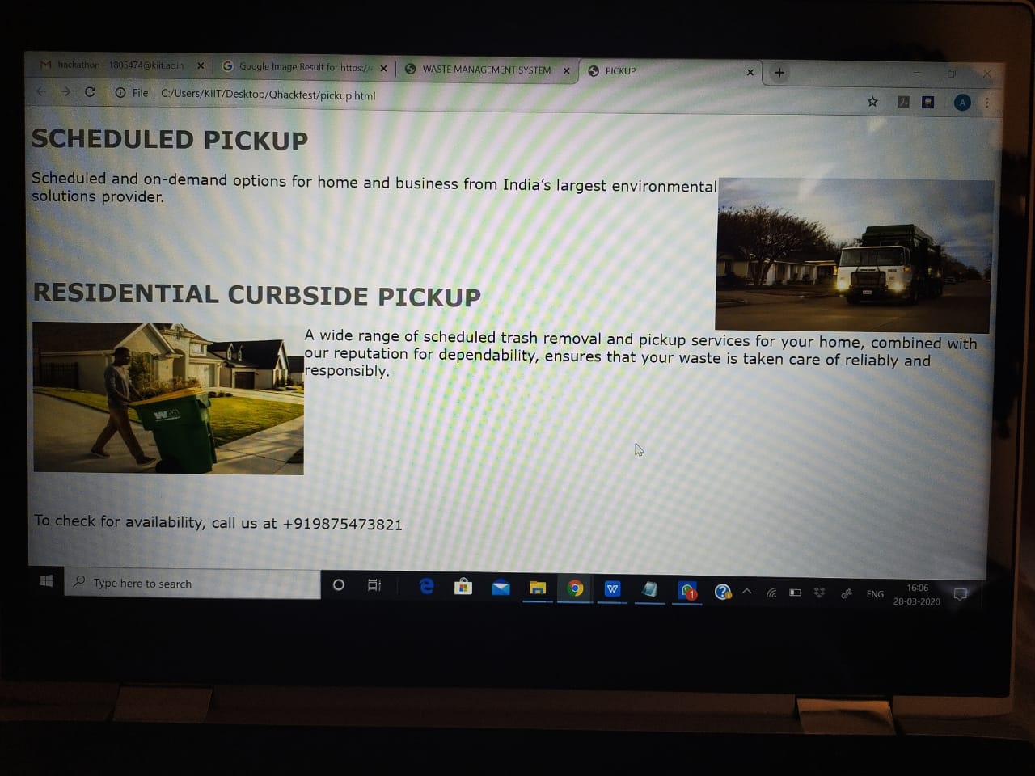

Also, we are making the ppt in which we will give detailed explanation of our redesigned waste (eg sewage) management system.

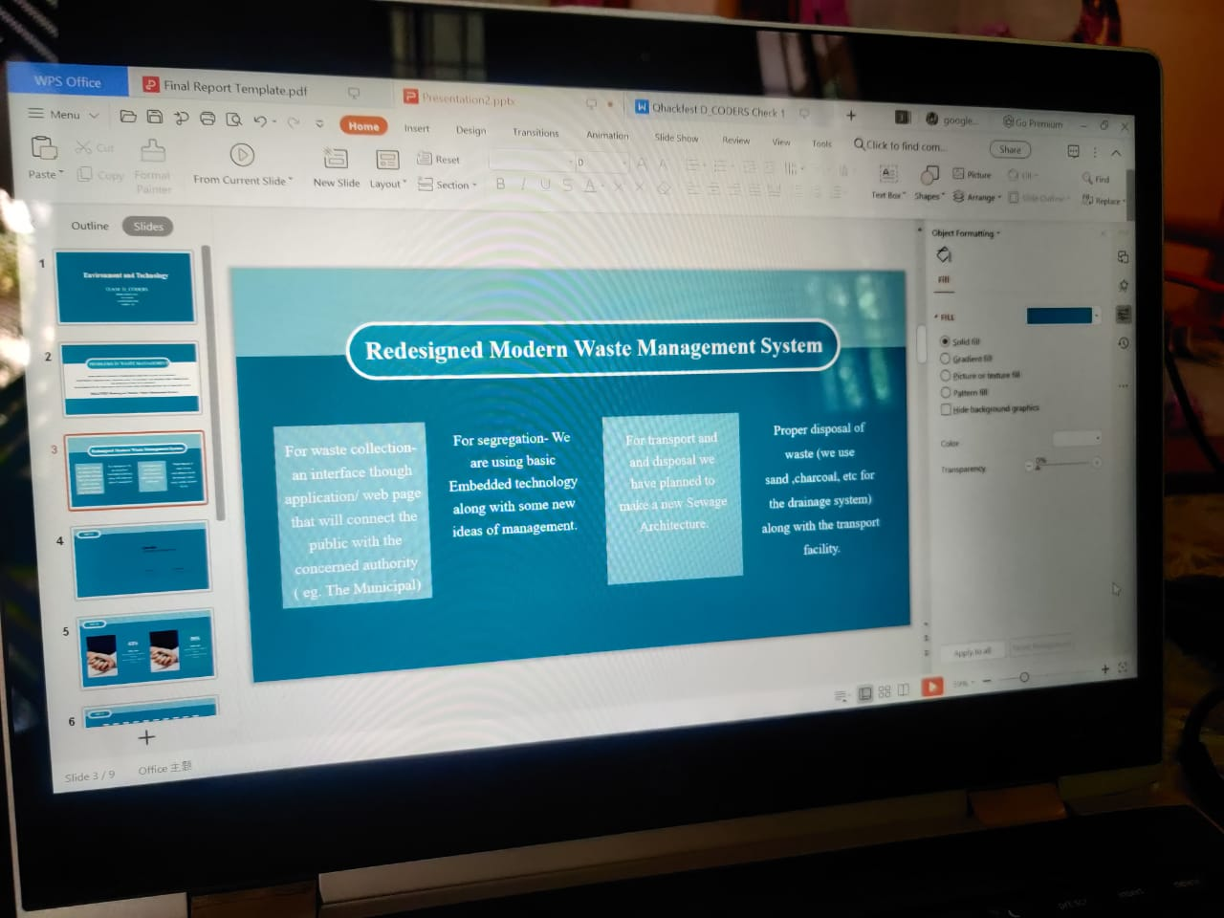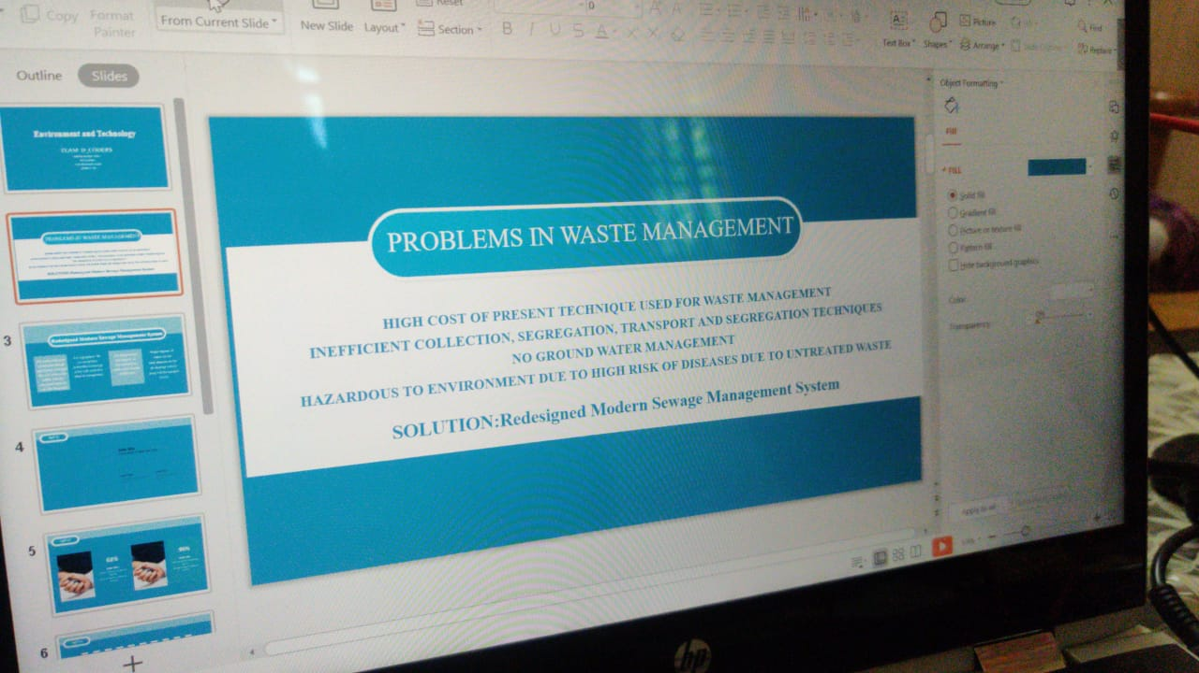

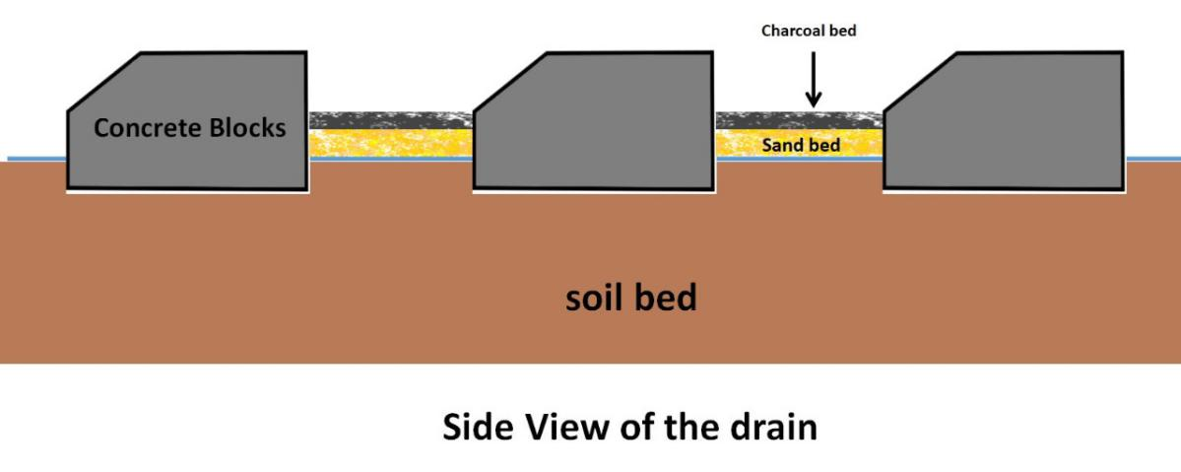

BASIC OUTLAY OF THE DRAINAGE SYSTEM